OUTPUT:

6a. CLUSTERING USING K-MEANS ON MAKE_BLOBS DATASETS

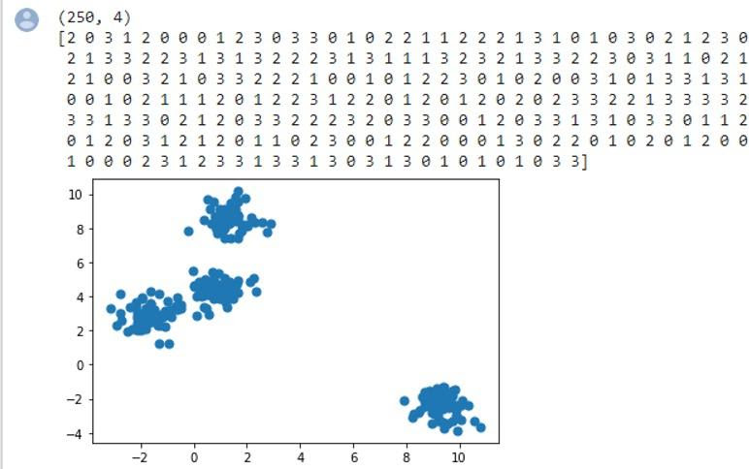

6b. CLUSTERING USING K-MEANS ON LOAD_IRIS

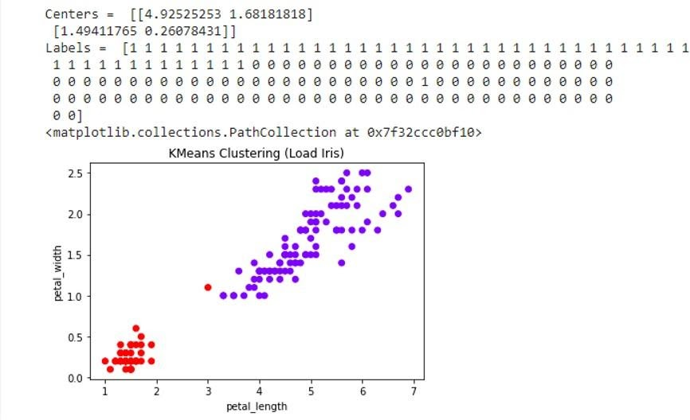

6c. CLUSTERING USING K-MEANS ON KAGGLE DATASET(2D)

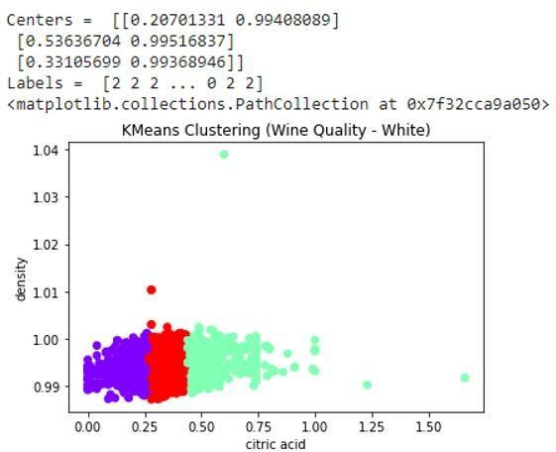

6d. CLUSTERING USING K-MEANS ON KAGGLE DATASET(3D)

